Rural Youth Mental Health Service (RYMH) Bila Muuji Board Members Report November 2018

Operational Update
- Program Logic, Operational tools and procedures, staff supervision and clinical leadership systems are finalised
- Recruitment of team has progressed well. We have 2 team vacancies. We would like to prioritise placing a team member in Coonamble or Walgett if we can attract someone from these areas. The panel recruitment with Bila Muuji representation has been a robust and professional partnership and worked well to recruit a strong team.
- Cultural Safety Framework self-checklist has been completed and development activities under Bila Muuji guidance are in progress.
- 6 referrals & 1 self-enquiry meeting between October 22nd – November 14th 2018
- 5 enquiry and referral preparation conversations with service staff eg. Wilcannia Forbes Catholic Care, Royal Far West, FACS, Lyndon Community
Location breakdown of referrals to RYMH service since 22nd October 2018
Cobar | 0 | Condobolin | 0 | Cowra | 0
Coonabarabran | 1 GP referral | Coonamble | 0 | Forbes | 1 referral Wilcannia Forbes Catholic Care *
Gilgandra | 1 Community referral from family member* | Walgett | 0 | Parkes | 1 community referral from partner *  1 self-enquiry meeting  1 CAMS referral  1 TBS referral
Nyngan | 0 | Narromine | 0
*Aboriginal Identified
RYMH Team
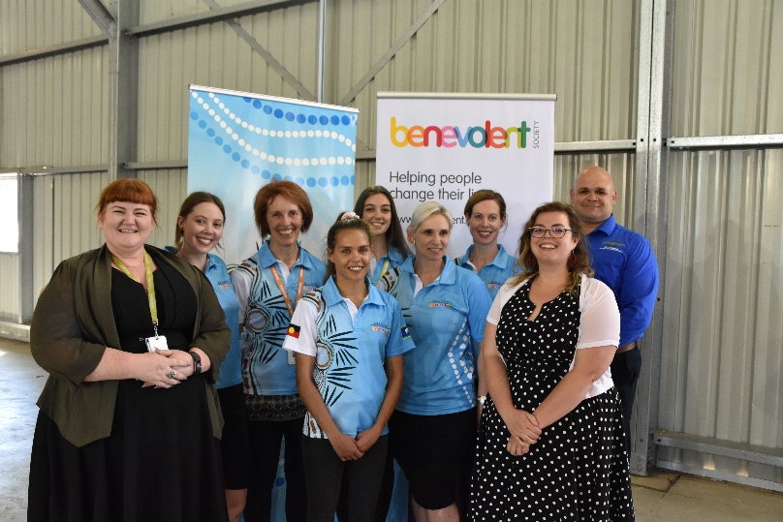
Team members from far left-
Beck O’Connor, Imogen Morrissey, Vicki Lyner, Rachael Gazzola, Kylie Manners, Phil Naden, Jinnara Tyson, Pam Renata, Amie Carrington

Team Practitioners- Vicky Lynar- Clinical lead, Orange Outreach.
Imogen Morrissey- Coonamble Outreach, Rachael Gazzola- Parkes Outreach, Jinnara Tyson –Dubbo Outreach, Katie Lees- Dubbo Outreach (plus vacancies).

Community Engagement Highlights
- Community Engagement Strategy Endorsed by Bila Muuji

- Program launch 22nd October in Parkes High School
On the 22nd October we launched the Rural Youth Mental Health Program (RYMH) in partnership with Bila Muuji. The launch brought together key speakers – Beck O’Connor- TBS, Phil Naden- Bila Muuji and Andrew Harvey – PHN WNSW, over 50 community and service representatives and 100 young people. The speakers provided current information about the relevance of the program to Rural and regional young people in Western NSW, the partnership between TBS and Bila Muuji and our commitment to cultural safety and reducing barriers for young people to access mental health supports. The RYMH team wore our co-branded Bila Muuji and RYMH jerseys and provided wellbeing and mental health awareness raising activities for young people.

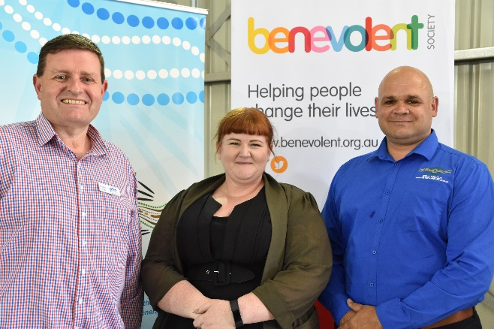smaa; Andrew
Andrew Harvey, CEO PHN Western NSW, Beck O’Connor, Director Child and Family Services Rural and Regional NSW The Benevolent Society, Pil Naden, CEO Bila Muuji Aboriginal Corporation Health Service

Summary of Community engagement highlights for each area
Parkes | Launch 22nd October  Invitation to speak at Parkes High School 29th November parent information evening, various conversations with High School staff about the service  Further partnership development meetings with Parkes High School underway
Forbes | Yoorana Gunya partnership development in progress. Rachel Gazolla outreaching on Wednesdays.
Coonabarabran | Interagency meeting attended 13 November 2018. RYMHs staff attended community expo 14th Nov, discussions with Landscouncil Chairperson and School underway
Condobolin | Rachael will be going to Condobolin on 14 November 2018 with Fiona Glasheen (Catholic Care Wilcannia Forbes) to be introduced to Condobolin High School staff.
Coonamble | AMS meeting, School partnership meeting – currently negotiating outreaching to the Coonamble High School to provide individual appointments to young people. .Jinnara, Katie and Imogen will outreach 1 day per week to provide in school appointments and local appointment at other locations in community (eg. AMS, Neighbourhood centre, GPs).
Walgett | Engagement and consultation planning in Progress for early 2019.
Nyngan | Engagement and consultation planning in Progress for early 2019.
Narromine | Interagency meeting attended 7 November 2018. Plan on outreach visits to occur weekly, likely to be a combination of Jinnara and Katie providing supports, early conversations regarding wellness hub support at high School in progress
Cowra | Meeting with OAMS to build local partnerships, Local Health District, Neighbourhood Centre, Cowra High School and Rural Adversity Mental Health Program (RAMPH).
Cobar | Engagement and consultation planning in Progress for early 2019.
Gilgandra | Looking to outreach into the High School Wellbeing hub early conversations in progress.

Service Development Planning
Priorities for service development throughout the next 3 months will be to further establish the program through;
- Building on relationships within the areas that we are funded to operate
- Developing Cultural Safety Framework initiatives for quality improvement
- Team development and learning activities outlined in the 6 month staff induction plan
- Increase service delivery to 50 clients
- Embed outreach service delivery in Gilgandra and Coonamble High School and Yoorana Gunya and apply the model to the development of other outreach location partnerships
Attachments
- RYMH service brochure
- RYMH service referral
- Parkes Times article

