**Research project**

**Career pathways for Aboriginal and Torres Strait Islander health professionals**

***Funded by the Lowitja Institute***

***Australia’s National institute for Aboriginal and Torres Strait Islander Health Research***

**Objective**  
Contribute to the growth, retention and career development of the Aboriginal and Torres Strait Islander health professional workforce, and to the improved health and wellbeing of Aboriginal and Torres Strait Islander people.

**Key questions include:**

* Reasons Aboriginal and Torres Strait Islander people come to work in health
* Unique skills and values that Aboriginal health professionals bring
* What managers look for in recruiting Aboriginal health staff
* Barriers and enablers for Aboriginal health workforces career development (roadblocks and stepping stones)
* Possible solutions and strategies to address the barriers and better enable Aboriginal health career pathways.

**Key components include:**

* Literature review – drafted
* Stakeholder engagement/consultations – ongoing
* Secondary data analysis – drafted
* National survey – UNDERWAY
* Individual career trajectory interviews (WA, SA, VIC, QLD & NT) – UNDERWAY
* Workplace-based focus groups and interviews (NSW & NT) – UNDERWAY
* Knowledge exchange and translation – focus for 2019, see NRH conference below.

**Workplace-based component**  
Designed to collect ‘ground-level’ data via yarning circles and interviews with Aboriginal health staff & their managers:

* Different locations: urban, regional/rural, remote
* Different organisation types: ACCHOs, LHDs, PHN
* 2 jurisdictions: NSW and NT.

NSW case studies

|  |  |  |  |
| --- | --- | --- | --- |
|  | **Urban** | **Regional/rural** | **Remote** |
| **ACCHO** | Awabakal | Bila Muuji | Marri Ma |
| **LHD** | SWSLHD* | WNSWLHD |  |
| **PHN** |  | WNSW PHN | |

*Data collection scheduled 19-26 November, 2018

**Data collection to date**

* 11 organisations (9 ACCHOs, 1 LHD, 1 PHN) and 15 sites
* 21 FGDs – 14 x staff and 7 x managers
* 64 staff and 33 managers.

**Joint team meeting**  
Last week, the NSW-based project team and the NT-based project team met in Sydney to look at the findings so far and plan next steps. There is still a lot to do before the revised project finish date of 31 May 2019.

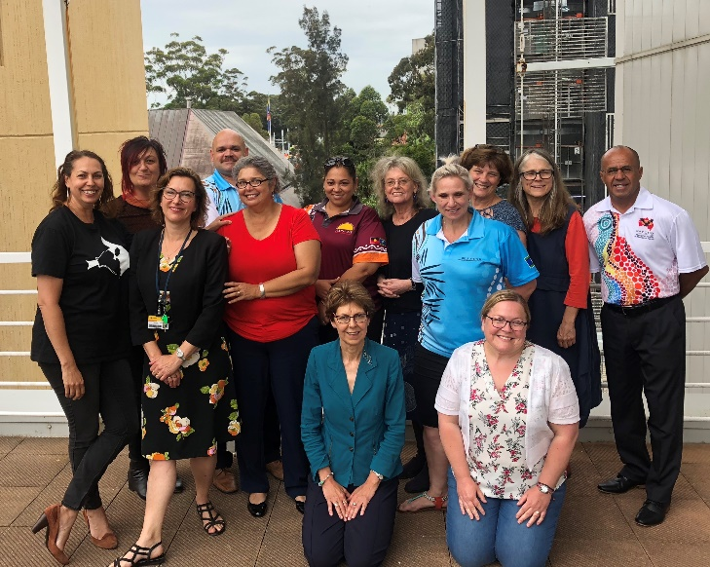

**Presentations**

In early November 2018, Jamie Newman and Karrina DeMasi (AMSANT) presented on Career Pathways Project at National Conference on Indigenous Health Workforce Leadership in Brisbane, as well as the 2018 NACCHO Conference.

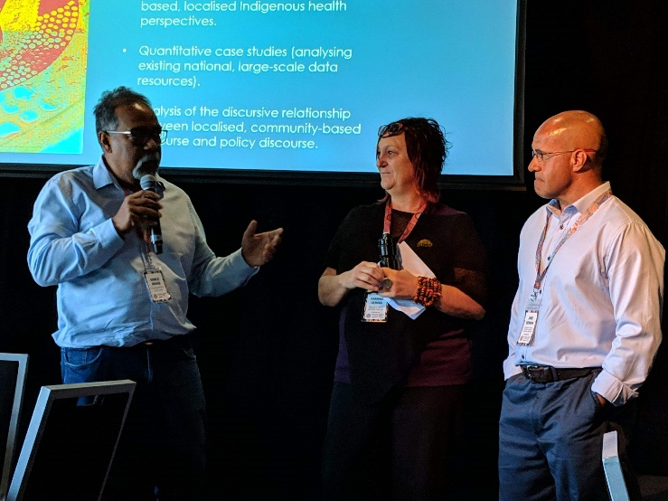

15th National Rural Health Conference, 24-27 March 2019, Hobart

<http://www.ruralhealth.org.au/15nrhc/general/about>

Described as ‘Australia’s premier rural health event’. Four days’ immersion in rural and remote health and wellbeing. A place to hear the latest developments, network with leaders from across the sector, and help set the rural health agenda for the next two years.

The conference theme is ‘Better Together!’ The research team submitted an abstract for an oral presentation based on Career Pathways Project findings in western NSW and it was accepted.

The presentation title is ‘Better together: working and growing together will enhance Aboriginal careers in health’. We would like Bila Muuji to nominate someone who participated in one of the yarning circles and who is interested in a career in Aboriginal health, and possibly research, to come with us to the conference.

**Please get in touch with Jannine Bailey** [**jannine.bailey@westernsydney.edu.au**](mailto:jannine.bailey@westernsydney.edu.au) **for further information and let Phil Naden know if you are interested**

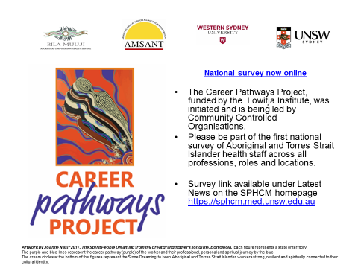

**Please promote the survey to any Aboriginal health staff who missed out on yarning circles**

Four with leaders from across the sector, and help set the rural health agenda for